CE on Wheels Request Form
Complete this form and submit to jennifer.carroll@annanurse.org. You will
receive an access code for selected session(s) and instructions on hosting a CE on Wheels Program.
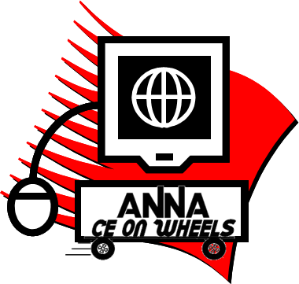
Chapter Name: Chapter #:
Contact Name: Date of the program:
Daytime Phone Number: E-mail Address:

Step One: Please select a session below.

Urgent Start Peritoneal Dialysis (PD): What Nurses Need to Know (Exp 5/5/2023) 1.00 CH/.50 Rx
Focusing on Mental Health Across the Lifespan (Exp 10/3/2024) 1.25 CH/1.25 Rx
Evaluation of Patient Frailty and Implications for Care (Exp 10/3/2024) 1.25 CH

Step Two: Set up your meeting location
Questions? Please contact Jennifer Carroll
856-256-2348
jennifer.carroll@annanurse.org
Location City: Location State:
Be sure that your location has the following:

Computer
A screen large enough for your audience
LCD (recommended for large audiences)
Audio speakers

Step Three: Advertise and promote your meeting! A flyer for the session you selected will be included with your program materials.

Step Four: Watch the program!

Step Five: Receive Contact Hours
To receive contact hours, participants will redeem a code in the Online Library, complete the evaluation, and print their certificate. A flyer that includes the code will be provided in your program materials.

Please note: While there is no charge for ANNA members for this program, the fee for nonmembers is $10.

