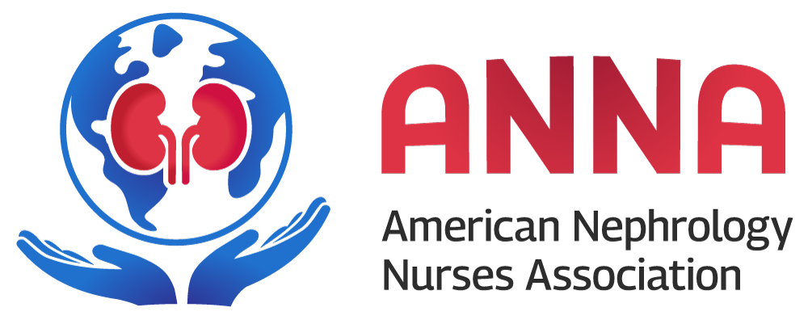 **MEDIA RELEASE**

**FOR IMMEDIATE RELEASE Contact:** Name Here

**DATE Phone:** ###-###-####

**Email:** example@example.com

**Combatting Hunger Locally: [Chapter Name] Hosts 'Feed Your Kidneys' Volunteer Drive**

[City, State, Date] — The [Chapter Name] of the American Nephrology Nurses Association (ANNA) is excited to announce its annual “Feed Your Kidneys” drive, dedicated to supporting local food banks and pantries throughout September. This year, our chapter is focusing on making a direct impact through a volunteer day at [Selected Food Bank/Pantry Name] on [specific date].

**Volunteer Day Details:**

* **Date and Time:** [Specific Date and Time]
* **Location:** [Selected Food Bank/Pantry Name, Address]
* **Activities:** [Brief description of the planned volunteer activities, such as sorting food, preparing meals, distributing supplies, etc.]

In addition to our volunteer efforts, the [Chapter Name] will present a $1,000 donation to [Selected Food Bank/Pantry Name] as part of the “Feed Your Kidneys” drive. This contribution aims to further support the vital services provided by the food bank to our local community.

"The [chapter name] Chapter is deeply committed to addressing hunger in our community," said [Chapter Leader's Name], [Position]. "By dedicating a full day of volunteer work at [Selected Food Bank/Pantry Name], we hope to make a tangible difference and inspire others to join us in this crucial effort."

The primary goal of the “Feed Your Kidneys” drive is to give back to the community through hands-on volunteer work and financial support. The [Chapter Name] aims to engage as many members as possible in organized activities that highlight the importance of community service and support for those in need.

**How to Get Involved:**

The [Chapter Name] encourages community members to participate in our volunteer work day to support the important work [Selected Food Bank/Pantry Name] is doing to help feed our community. For more information on how to volunteer or donate, please contact [Your Name] at [Your Email Address] or [Your Phone Number].

**About ANNA:**

The American Nephrology Nurses Association (ANNA) is a professional organization committed to advancing nephrology nursing practice and positively influencing outcomes for individuals with kidney disease. ANNA provides education, research, and advocacy to promote excellence in and appreciation of nephrology nursing.

For more information about the “Feed Your Kidneys” drive and other initiatives by the [Chapter Name], visit [Chapter Website/Contact Information].

###

Since it was established as a nonprofit, nonpartisan organization in 1969, ANNA has been serving members who span the nephrology nursing spectrum. ANNA has a membership of thousands of registered nurses and other health care professionals at all levels of practice. Members work in a variety of settings including education and prevention, home dialysis, outpatient dialysis, continuous kidney replacement therapies in intensive care units, pediatrics, transplantation, industry, and government/regulatory agencies.

ANNA is committed to advancing the nephrology nursing specialty and nurturing every ANNA member. We achieve these goals by providing the highest quality educational products, programs, and services. Our members are leaders who advocate for patients, mentor each other, and lobby legislators, all to inspire excellence.